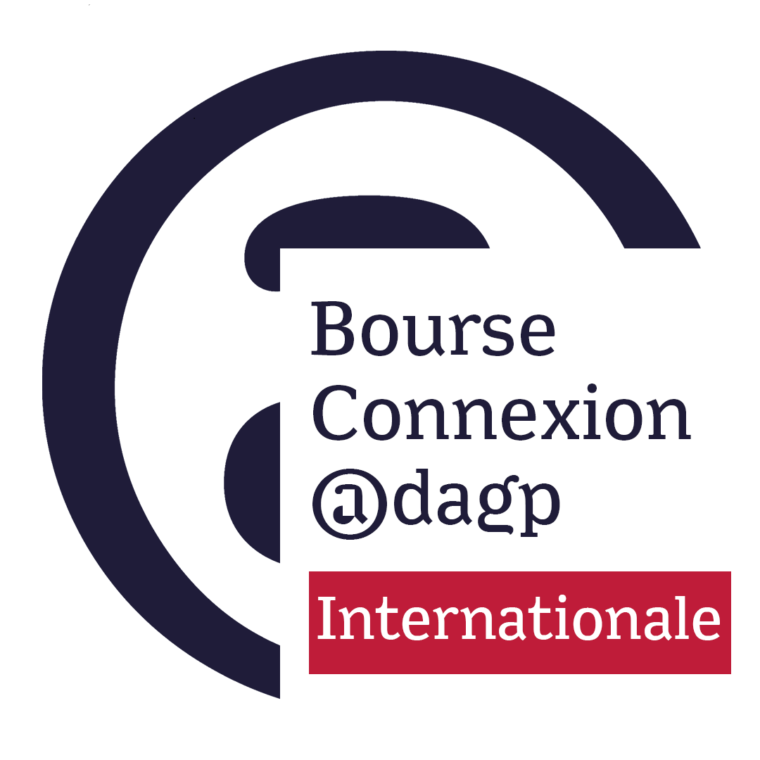
APPLICATION FORM 2023-2024

Application from : (Name of the applicant organisation)
For : (Visual art/Photography/Comics/Children’s book)

SUMMARY

ADMINISTRATIVE FILE

- Application form,
- Presentation of the German venue, promoter of the project (status, contact details, artistic programme and international impact, press reviews) - 2 pages maximum
- Letter of commitment from the German venue to present an exhibition by an artist from the French scene

ARTISTIC FILE

- Presentation of the project: detailed description of the artistic project (is it a festival, an exhibition, a biennial, a triennial, the dates of the event), clearly stating the essential ideas, the objectives of the project, including the curator's note of intent including his or her curatorial intentions (PDF - Max. 2 pages).
If the exhibition project is realized in partnership with a French structure, presentation of the French structure (10 lines max.)

- CV of French artist(s), a link to the website of each artist or a portfolio of 10 works, (1 page maximum)

- Curator's CV with training, research and full contact details, (1 page maximum)

TECHNICAL FILE

- Detailed and balanced budget estimate showing the expenses specific to the operation (insurance, transport, copyright, etc.), the income and financing plan (grants, subsidies or financial partnerships acquired or in the process of being acquired, including the amount requested from the ADAGP) (1 page maximum)

- The provisional timetable

ADMINISTRATIVE FILE

1) Application form
Applicant
Name of the project executing organisation: ……………………………………………………….
Name of the person in charge: ……………………………………………………………………………
Adress: ……………………………………………………………………………………..………………………
Postal code: ………………………………….. City: …………………………………………………………..
Telephone: …………………………………………………………………………………………………….…
Mail: ………………………………………………………………………………………………………………….
Website: …………………………………………………………………………………………………….………
Legal form: …………………………………………………………………….…………………………………….
SIREN / SIRET number: ………………………………………………….…………………………………….
Date of creation of the structure: …………………………………….………………………………………..
How did you find out about this funding programme? …………………………………………………..

☐ I certify the conformity of the documents submitted in this application and that all the information provided is accurate.
☐ I declare that I have read the Connexion scholarship rules and accept them in full.
Place …………………………………………………………………………………………………….
Date …………………………
Signature preceded by "Read and approved".
2) Presentation of the applicant German venue

(Presentation in 2 pages maximum: including its programme and artistic objectives, the curator's note of intent including its curatorial intentions)

3) Letter of commitment from the German venue to present artists from the French scene in its space

DOSSIER
ARTISTIQUE

- Presentation of the exhibition project

(Detailed description of the artistic project clearly outlining the essential ideas and objectives of the project, including the curator's statement of intent including his or her curatorial intentions; (PDF - Max. 2 pages).

- CVs of French performing artists

( Please add the link to the website of each artist or a portfolio of 10 works)
- Curator's CV

(1 page presentation with training, research and full contact details)

TECHNICAL
FILE

- Detailed provisional budget

With the expenses specific to the operation and the financing plan (with the grants, fundings or financial partnerships acquired or in the process of being acquired), balanced against the expenses.

- Provisional timetable

